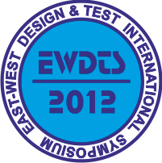
10th EAST-WEST DESIGN & TEST
SYMPOSIUM (EWDTS 2012)

Kharkov, Ukraine, September 14-17, 2012
Call for Papers

The main target of the IEEE East-West Design & Test Symposium (EWDTS) is to exchange experiences between scientists and technologies of Eastern and Western Europe, as well as North America and other parts of the world, in the field of design, design automation and test of electronic circuits and systems. The symposium is typically held in countries around the Black Sea, the Baltic Sea and Central Asia region. We cordially invite you to participate and submit your contributions to EWDTS’12 which covers (but is not limited to) the following topics:
- Object-Oriented System Specification and Design
- On-Line Testing
- Power Issues in Design & Test
- Real Time Embedded Systems
- Reliability of Digital Systems
- Scan-Based Techniques
- Self-Repair and Reconfigurable Architectures
- Signal and Information Processing in Radio and Communication
Engineering
- System Level Modeling, Simulation & Test Generation
- System-in-Package and 3D Design & Test
- Using UML for Embedded System Specification
- CAD and EDA Tools, Methods and Algorithms
- Design and Process Engineering
- Logic, Schematic and System Synthesis
- Place and Route
- Thermal, Timing and Electrostatic Analysis of SoCs and Systems on Board
- Wireless and RFID Systems Synthesis
- Digital Satellite Television
- Analog, Mixed-Signal and RF Test
- Analysis and Optimization
- ATPG and High-Level Test
- Built-In Self Test
- Debug and Diagnosis
- Defect/Fault Tolerance and Reliability
- Design for Testability
- Design Verification and Validation
- EDA Tools for Design and Test
- Embedded Software Performance
- Failure Analysis, Defect and Fault
- FPGA Test
- HDL in test and test languages
- High-level Synthesis
- High-Performance Networks and Systems on a Chip
- Low-power Design
- Memory and Processor Test
- Modeling & Fault Simulation
- Network-on-Chip Design & Test
- Modeling and Synthesis of Embedded Systems

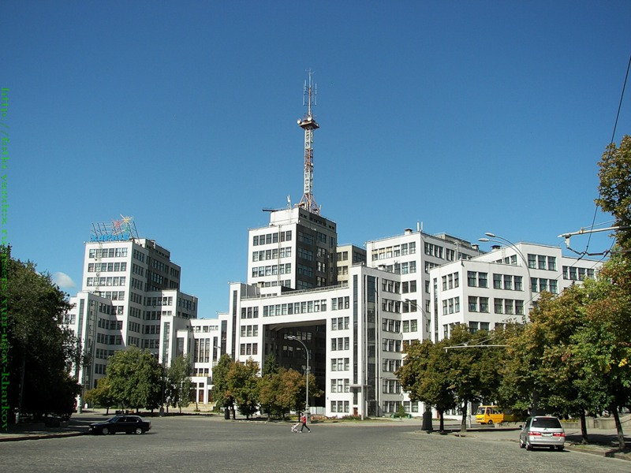
General Chairs
V. Hahanov – Ukraine
Y. Zorian – USA
General Vice-Chairs
R. Ubar – Estonia
P. Prinetto – Italy
Program Chairs
S. Shoukourian – Armenia
D. Speranskiy – Russia
Program Vice-Chairs
Z. Navabi – Iran
M. Renovell – France
Publicity Chairs
S. Mosin – Russia
G. Markosyan – Armenia
Public Relation Chair
- Djigan – Russia
Program Committee
E. J. Aas – Norway
J. Abraham – USA
M. Adamski – Poland
А. Barkalov – Poland
R. Bazylevych – Ukraine
V. Djigan – Russia
A. Drozd – Ukraine
E. Evdokimov – Ukraine
A. Chaterjee – USA
E. Gramatova – Slovakia
A. Ivanov – Canada
M. Karavay – Russia
V. Kharchenko – Ukraine
K. Kuchukjan – Armenia
W. Kuzmicz – Poland
A. Matrosova – Russia
V. Melikyan – Armenia
O. Novak – Czech Republic
Z. Peng – Sweden
A. Petrenko – Ukraine
D. Puzankov - Russia
J. Raik – Estonia
A. Romankevich – Ukraine
A. Ryjov – Russia
R. Seinauskas – Lithuania
S. Sharshunov – Russia
A. Singh – USA
J. Skobtsov – Ukraine
V. Tverdokhlebov – Russia
V. Vardanian – Armenia
V. Yarmolik – Byelorussia
Steering Committee
M. Bondarenko – Ukraine
V. Hahanov – Ukraine
R. Ubar – Estonia
Y. Zorian – USA
Organizing Committee
S. Chumachenko – Ukraine
E. Litvinova – Ukraine
V. Kharchenko – Ukraine
G. Krivoulya – Ukraine

The Symposium will take place in Kharkov, Ukraine, one of the biggest scientific and industrial center. Venue of EWDTS 2012 is Kharkov National University of Radioelectronics was founded 81 years ago. It was one of the best University of Soviet Union during 60th - 90th in the field of Radioelectronics. Today University is the leader among technical universities in Ukraine.
Symposium Deadlines:
Submission deadline: June, 15, 2012
Notification of acceptance: August, 1, 2012
Papers submission info: http://www.ewdtest.com/conf
Organizing committee address: Prof. Vladimir Hahanov, Design Automation Department, Kharkov National University of Radioelectronics, Lenin ave, 14, Kharkov, 61166, Ukraine.
Tel.: +380-57-702-13-26, E-mail: hahanov@kture.kharkov.ua, www.ewdtest.com/conf/
The symposium is organized by Kharkov National University of Radio Electronics, in cooperation and sponsorship with Tallinn University of Technology. It is technically co-sponsored by the IEEE Computer Society Test Technology Technical Council (TTTC) and financially supported by Aldec, Synopsys, Kaspersky Lab, Cadence, DataArt Lab, Тallinn Technical University, JTAG Technologies.
The best reports, made in the Symposium will be published in IEEE Design & Test Magazine and Radioelectronics and Informatics Journal (ISSN 1563-0064); the last one is serving electronic test professionals in concurrence with the Test Technology Technical Council (TTTC) of the IEEE Computer Society.



