

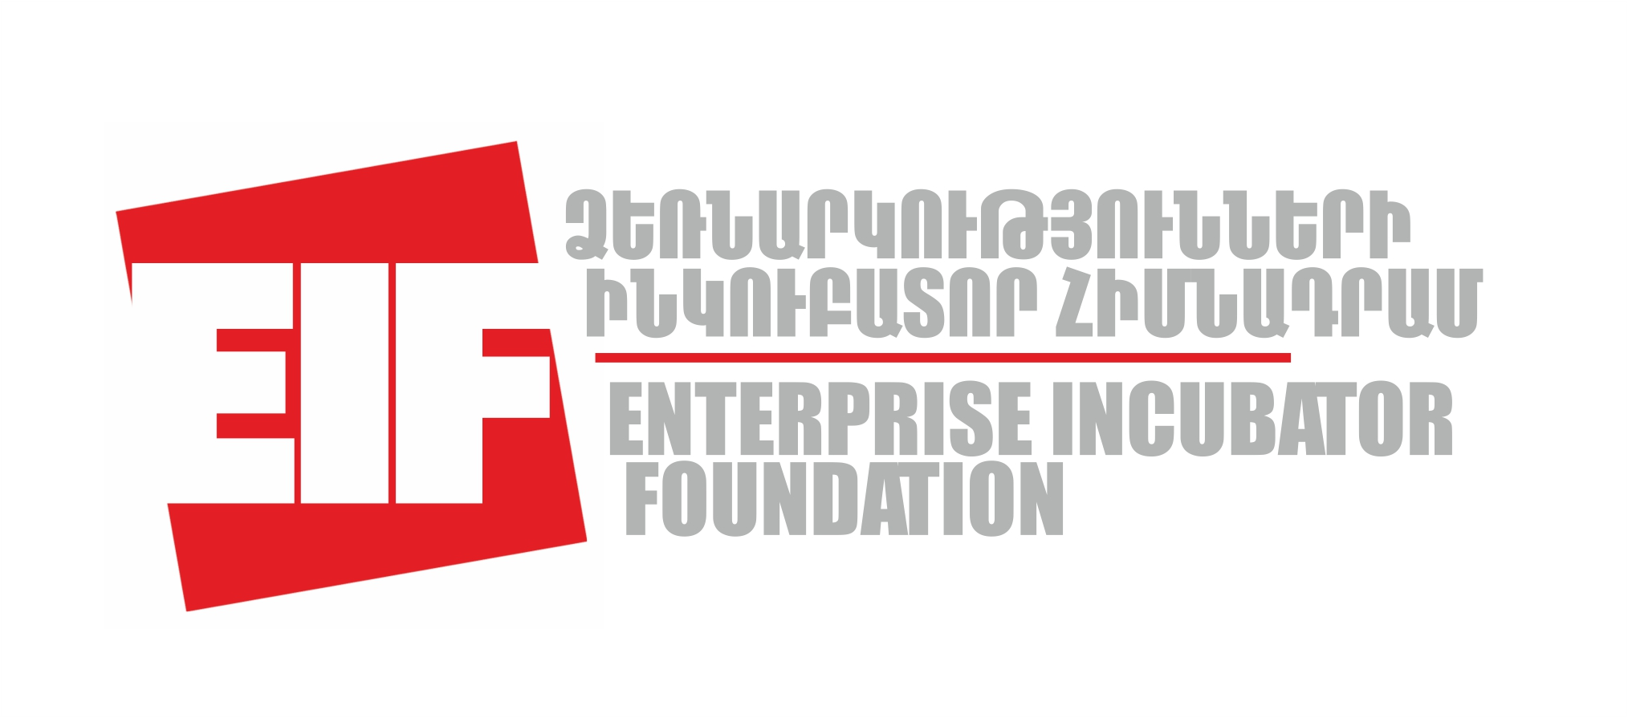

Smart Contest and IBM Mentor Day

Annex 1: Application form
The application form and the CVs of the team must be submitted electronically to info@eif.am with copy sent to sona.kochkanyan@eif.am . Contact info: Enterprise Incubator Foundation, 123 Hovsep Emin street, 0051, Yerevan. Phone: +374 10 219728.

I. Basic Information
- Technology Product/Service Name: ______________________________________

2. Team Leader: _______________________________________________________

3. Team Organization(s)/Institution(s): _______________________________________

II. Summary
Provide a summary of your technology product/service (not to exceed 1 page) – The summary should include key highlights about your product/service (focusing on the problem your technology will help solve and what IBM technology will be used in development of your product/service)

III. Your Product/Service

- What specific market problem(s) will the proposed technology will be able to solve? Please use non-scientific language accessible to general audience:

- How is your technology innovative?

- What is the current development status of your product/service?
- Concept
- Laboratory Prototype
- Commercial prototype
- Product/service ready to sell

- What is your commercialization/market entry strategy?
- Technology Licensing
- Strategic Alliance
- Contract R&D
- Startup

IV. The Team
1. Provide a brief description of the experience, credentials and the capability of the personnel. Why is it a winning team? No longer than half a page

2. Team Personnel
Please list the full names, dates of birth of all participants and their position title. List the team leader first. Add as necessary

