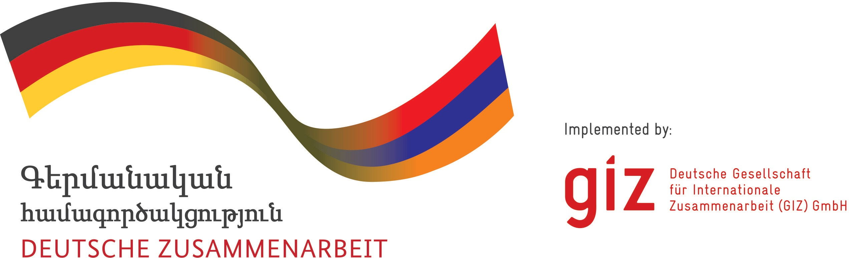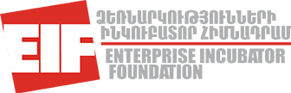

ANNOUNCEMENT

Innovation Matching Grants – Business Development Support for innovative technology oriented Start-ups and companies

The EU4Business "Support to SME Development in Armenia" (SMEDA) project, which is co-funded by the European Union and the German Federal Ministry for Economic Cooperation and Development (BMZ) and implemented by GIZ’s Private Sector Development in South Caucasus Programme, in cooperation with Enterprise Incubator Foundation announces “Innovation Matching Grants – Business Development Support for innovative technology Start-ups” grant competition.

The aim of the project is to support technology-oriented ventures and to increase the competitiveness of existing SMEs by providing financial and technical assistance to develop new innovative products and services for domestic and global markets.

Furthermore, the project aims at stimulating the rate of technology absorption, technology transfer, innovation, and commercialization of research ideas in the private sector, and also fostering the collaboration between research centers and SMEs. In particular, the programme emphasizes the support of the development of viable technology enterprises in regions of Armenia, such as Gyumri and Vanadzor.

Competition is open to companies with technology background, as e.g. in the field of Engineering, CleanTech, Biotech, Advanced ICT (e.g. AI, Blockchain) etc., who are registered in the Republic of Armenia and are able to provide necessary co-financing. Sole entrepreneurs are not eligible to apply.

Activities covered by the grant are:
- Development of industrial prototype
- Production/Manufacturing
- Market Validation
- Product Launch
- Market entry/Customer acquisition
- Market Expansion

GRANT AMOUNT & CO-FINANCING REQUIREMENTS
The amount of grant per initiative is 35.000 EUR (the contract shall be concluded in AMD, EUR/AMD exchange rate would be determined based on the Armenian Central Bank exchange rate announced at the date of the winner notification). Up to 9 grants will be provided with project duration of 9 months.

Innovation Matching Grants (IMG) is open to companies from all over Armenia, and provides funding for maximum 50% of co-financing of project expenditures estimated by the applicant.Companies from regions (such as Gyumri, Vanadzor, etc) applying to the grant will have privilege of being provided up to 85% financing from the grant funds when the company location is minimum 50km distance from Yerevan.To support the development of technology cluster in Gyumri and Vanadzor companies, from Yerevan who want to extend their businesses with majority of project’s business operations being based in the regions are also eligible for 85% financing.

ELIGIBILITY CRITERIA
- SME or startup should be registered as legal entity in Republic of Armenia as an LLC, OJSC or CJSC. Note: Sole entrepreneurs and unregistered teams are not eligible to apply.
- In alternative unregistered startup teams (comprised of at least two people) can apply, if their project/technology has a high Technology Readiness Level (TRL). The team and the companies should mention in a written form, that technology have completed the technology validation in the lab environment (TRL 4) and the technology was validated in relevant environment (TRL 5) i.e. the basic technological components integrated with reasonably realistic supporting elements have been tested in a simulated environment. More information on this you find below.
- The applying company should be innovative and technology-oriented and the suggested project should have a high-technology – focus. This doesn’t incorporate, e.g web applications and platforms, such as e-commerce, and other e-service platforms, mobile applications and services, solutions for business process automation.
- All applicants must submit self-statement letter on providing of the necessary co- financing of the grant funds in cash, if awarded the grant to be eligible for proposal evaluation.
- The applicants need to be a legal entity incorporated in Republic of Armenia and the main shareholder(s) - more than 51% shares - has citizenship of the Republic of Armenia or legal entity incorporated in Republic of Armenia.
- Projects with a focus on developing products or services for military use are not eligible. This also incorporates dual use technologies if the targeted customers are military or security forces.

ELIGIBLE COSTS

Eligible Expenditures under all grants programs. Include the following types:
- Hardware
- Software,
- Project related Staff salaries,
- Certifications,
- Marketing and sales, legal, accounting, Business development and other services and expenses
- Utilities, Communications, office rent and supplies.
- Travel allowances in justified cases. Armenian legislation and GIZ rules should be applied.
The indirect cost of the project should not exceed 7% of the project budget and should be agreed by EIF, in regard of their relevance for the aim of the grants.

APPLICATION AND EVALUATION PROCESS

The evaluation after submission within the IMG program is done in multiple stages:
- Eligibility check
- Stage 1- Evaluation by independent experts and creation of shortlist (~15 candidates)
- Mentoring – to attend Venture Forum a satisfactory recommendation by the mentor is necessary
- Stage 2 - Venture Forum, selection of up to 9 winners

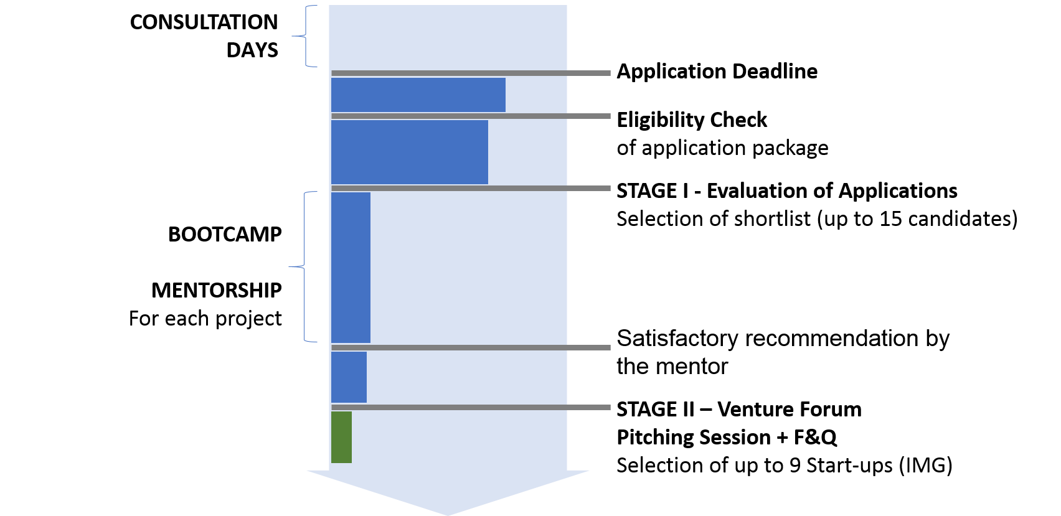

The Evaluation of the candidates will be done based on the following main criteria:
- Capability of the Team
- Product/service and Commercial Potential
- Understanding of Market and Customer Need
- Risks and opportunities
- Feasibility of the Implementation Plan
- Financials Projections

COMPETITION TIMELINE

Innovation Matching Grants competition - Call for proposals
Information Sessions for Interested Applicants  Dates might be changed! Information is available on EIF FB page | YSU-ISTC-March 15  Gyumri-GTC- March 16  Vanadzor-VTC- March 16,  NAS RA- March 20  RAU-EIF- March 22  AUA-EPIC- March 26
EIF Consultation hours | From 13.03 to 02.04.2018  Every Tuesday & Thursday 15:00-18:00  Every Wednesday 11:00-13:00
Application Deadline | April 3, 2018, 23:59 Yerevan Time
Selection of eligible applications | April 19, 2018
Selection of shortlisted candidates | May 10, 2018
Bootcamp for shortlisted applicants | May 19-20, 2018
Mentorship/Consultation* | May 21- June 20, 2018
Selection of Winners in the Venture Forum | June 25, 2018
Award Ceremony | June 25, 2018
Grant contracts starting date | August 1, 2018
During the grant implementation quarterly reports should be provided by grantees as well as ongoing monitoring of the projects will be implemented. Also, mentorship and coaching services will be available for grantees.

APPLICATION PACKAGE

- Completely filled-in Application Form
- Annex I - Project Budget only in EUR. (the contract shall be concluded in AMD, EUR/AMD exchange rate would be determined based on the Armenian Central Bank exchange rate announced at the date of the winner notification).
- Annex II - Projected Cash Flow for 3 years
- Annex III - Declaration on providing the co-financing funds to meet matching contribution of Grantee
- Annex IV - CVs of the project team members demonstrating competency and any experience relevant to execution on the proposed project
- Annex V - Copy of Company’s registration certificate and self-statement on majority of shareholders being located in Armenia
- Annex VI - For Gyumri and Vanadzor companies extending their operations statement letter on having all the major operations based in Gyumri or Vanadzor
- Annex VII- Intention letter on registering a company

SUBMISSION OF GRANT APPLICATION

Applications must be submitted in English online via following link:
https://goo.gl/forms/tNqrtDpSRS7mArM13

The required annexes need to be uploaded in the online form. The original documents will be required upon necessity.
The documents for the application package (question catalog of online form and annexes) you find below.

Deadline for application submission is April 3, 2018, 23:59 Yerevan Time.

It is strongly recommended to apply before the deadline to avoid any technical difficulties with online uploading of the files! Please be aware of the indicated max. size of upload.

Please be aware that the online form cannot be auto saved or later on edited.

In case of several versions please note that the last uploaded will be considered as valid submission. Information provided in former versions will not considered for evaluation!

The link to the application form will be automatically closed after the deadline. For all interested candidates, orientation sessions will be organized to provide more information on application process and answer all the questions.

SUPPORT TO GRANT PROJECT ELEBORATION

For all the interested candidates EIF will provide consultation hours to answer all the questions related to the application. It is highly recommended to discuss project proposal during the consultations upfront

This support gives recommendations regarding the completeness of application packages and eligibility of project proposals. Furthermore, unbinding directions regarding expected scope of projects and proposal can be provide.

The schedule of consultation hours:
- Every Tuesday and Thursday from 15:00-18:00 at EIF building (123 Hovsep Emin str.)
- Every Wednesday from 11:00-13:00 at EIF building

In case of any questions, please feel free to contact us:
by sending an e-mail to grantimg@eif.am or calling to +37410 219797.

The mentioned consultations to interested applicants have an advisory nature and it is not mandatory to follow them. No legal consequences may derive. The selection of competition winner is upon independent evaluation.

DOWNLOAD APPLICATION MATERIALS

Innovation Matching Grants competition – Materials.
You can download all the corresponding documents from here.
Application Form | The application needs to be submitted in online form.  The questions requested in the form you find here:  http://bit.ly/2FANVuM
Annex I | http://bit.ly/2FBekZC
Annex II | http://bit.ly/2FIt6AR
Annex III | http://bit.ly/2Fq6qWR
Annex IV | For the CVs of team members, no special format is required.
Annex V | In this Annex scan of originals are required
Annex VI | http://bit.ly/2DhLV8T
Annex VII | http://bit.ly/2FzmOAm

SELFEVALUATION OF THE APPLICANTS
It is mandatory that all applicants self-classify the level of development of the products/services
within their projects in the Technology Readiness Level (TRL) and indicate the envisaged level
of development after 12-month grant period.

Technology  Readiness Level | Description
TRL 1. | basic principles observed
TRL 2. | technology concept formulated
TRL 3. | experimental proof of concept
TRL 4. | technology validated in lab
TRL 5. | technology validated in relevant environment (industrially  relevant environment in the case of key enabling technologies)
TRL 6. | technology demonstrated in relevant environment (industrially  relevant environment in the case of key enabling technologies)
TRL 7. | system prototype demonstration in operational environment
TRL 8. | system complete and qualified
TRL 9. | actual system proven in operational environment (competitive  manufacturing in the case of key enabling technologies; or in space)

The applicants should scan his project regarding potential challenges regarding IP infringements
and necessity of protection of intellectual property rights and indicate this in the application.

